UI Design And Evaluation

CS39930 – Web Based Major Project

Ryan Jones – RYJ7

Contents

Introduction 3

Website Structure 3

Navigation diagram 3

Design And Prototype 4

Design 4

Landing Page 4

Login Page 5

Home Page 6

Recipes Page 7

My Recipes Page 8

Shopping List Page 9

Account Page 10

Add Recipes Page 10

Edit Recipes Page 11

Selected Recipe Page 12

Admin Page 14

Evaluation 15

References 21

Appendix 22

# Introduction

The web-based project that I have decided to build is a meal planner that allows the user to look through recipes created by themselves and their close friends and family to add to this planner. There will also be an option to create a shopping list from the recipes selected in the weekly planner.

The customers/users of this site are my close friends and family to allow them to share recipes efficiently and in a clear format as well as making them easily accessible. The customer also wants to ensure that meal planning and shopping trips are efficient.

The people that want to be built will be the users/customers as it is for people who are interested in cooking as well as wanting to share the recipes with their friends.

# Website Structure

## Navigation diagram

Figure 1 shows the pages of the site and how they will be linked along with what each of the different users will be able to access. As the administration account is only there for managing users, they will only need to access the landing page, login page and the admin page. The admin page will allow the admins to change passwords and delete users if needed. Normal users have access to almost everything on the site apart from the admin page for security reasons. Normal users will be able to carry out all of the required functions on these pages in as few clicks as possible. To allow the user to do what they want to do in as few clicks as possible, all of the important pages have been put at higher levels in the diagram with only the pages that require more user input taking longer to access.

The add and selected recipes pages will all be able to be accessed from “My Recipes” and the recipes page but the edit recipes page will only be available from the “My Recipes” page to stop users from editing recipes they did not create. The edit and add pages will contain forms to create and edit the recipes and once created or edited, will appear on the recipes page.

Figure 1. Navigation diagram of the site

# Design And Prototype

## Design

When working on this design, Bootstrap was kept in mind when thinking about the layout to ensure that the site will be as close to the prototype as possible. The cards that are used are part of the Bootstrap library that create a simple card that can be used to split information or display it clearly.

The pages have been designed to cover each of the use cases in a clear way to make them easy to understand for all users.

## Landing Page

The landing page is the first thing the user will see when loading up the site. It contains a brief description of what the site does and what the user needs to do to register (Figure 2). Everything is the same when it comes to the content when on mobile other than the navigation bar being in a burger menu to save space. There is also a link in the text to make it easier for users to get to the login/registration page as they can click on it while reading the description.

The mobile version of the site will contain a burger menu to save space and to make sure that the site does not look too crowded (Figure 3).

Figure 2. Landing page view.

Figure 3. Landing page view with burger menu open.

## Login Page

The login page contains the forms for both logging in and registering as number of users is limited to whoever has access to the key (Figure 4). This is a closed system to be used by a small number of close friends and family members. The key is given out by current users. The forms are clearly separated with large headers to make sure the users knows what form to fill in.

Figure 4. Login/ Registration page on mobile and a wider screen.

## Home Page

The home page contains the meal planner as this is the focus point of the site to help plan meals easily (Figure 5). Each of the meals can be viewed by clicking on the meal names. To add meals to this planner, users will have to browse the recipes and add them through that page. The aim is to make the planner as clear and as minimal as possible to make sure that users can easily see what they want to see quickly.

The navigation bar contains all of the major pages in the site to avoid having to go through multiple pages to get to what the user wants to do. An example of this is the “my recipes” page being on the navigation bar instead of being an option inside of recipes. This page means that the user can quickly access their recipes without having to go to the recipes page, then search for their name. This is also the reason why the shopping list is in the navigation bar also, to avoid having to go through multiple pages to get to the correct content.

Figure 5. Home page that contains the meal planner.

Figure 6. Home page with the burger menu expanded on the mobile design to show the extra options available when logged in.

## Recipes Page

The recipes page contains all of the recipes that users can view (Figure 7). Each of the recipes can be viewed by clicking on the cards. The recipes can be sorted and searched for using the search bar and the sort button. The sort option will have the option to sort by user and alphabetical ascending and descending. The layout is the same for mobile but the cards will be displayed differently depending on screen size.

In previous versions there was not an add recipe button to make a new recipe. This button was added due to the feedback given in the questions in the evaluation. The desk top version of this site will contain a button that has the text “Add recipe” whereas the mobile version will contain a button that has a “+” symbol in it to save space. Using the “+” symbol is well known to mean add something and in this case to add a recipe.

Figure 7. Recipe page with the cards that have the name, picture and user that created the recipe.

## My Recipes Page

The “My Recipes” page does not display pictures of the recipes, just the name and the option to delete and edit them (Figure 8). The pictures are only there on other pages to make it easier for others to find the recipe they want. The option to edit and delete the recipes are exclusive to the person who made them which is the main reason for this page as it makes it easier to sort through the recipes. A simple query to get all of the recipes made by a specific user will make it easy to display this data and edit or remove them if needed.

Figure 8. The "my recipes" page to show all of the recipes that the user has made.

## Shopping List Page

The shopping list page will be a list that has extracted all of the ingredients from the recipes that have been saved in the weekly planner (Figure 9).

After getting feedback from the questionnaire having a way to add and remove from the list would be useful and could easily be a button below the list similar to how ingredients are added to recipes. To save these extra items would raise questions on how they would be stored for if the user closes the site. This data could be stored locally or in a separate column in a table that is linked to the user.

Figure 9. Shopping list page that shows the ingredient, amount and a check box to tick it off when shopping.

## Account Page

The account page will allow users to log out, change their username and password as well as delete their account (Figure 10). The Key will be displayed here so users can share it to their friends.

This page covers some of the use cases including being able to log out, remove account, change password and username. This gives users more options to change their information if they get anything wrong in the initial account creation process.

Figure 10. Account page to change account details once logged in.

## Add Recipes Page

Add recipe page has all of the key sections to make the recipe (Figure 11 and 12). To add ingredients the user will type in an ingredient, an amount along with its unit and then press the “add ingredient” button to add an ingredient to the list. Once the form has been filled out the user can then confirm and make the recipe or cancel it. The recipe will then be made and displayed on the recipes page.

Figure 11. Add recipe page (top part).

Figure 12. Add recipe page (bottom part).

## Edit Recipes Page

The edit recipe page is similar to the add recipe page but it will update an already existing recipe (Figure 13 and 14).

Figure 13. Edit recipe page (top part).

Figure 14. Edit recipe page (bottom part).

## Selected Recipe Page

The selected recipe page will display a full recipe and will give the user the option to add the meal to their planner (Figure 15 and 16). On this page users will be able to add the recipe to their planner by selecting the day of the week in the dropdown menu in the popup (Figure 17).

Figure 15. Selected recipe page (top part).

Figure 16. Selected recipe page (bottom part).

Figure 17. Dropdown for day of the week selection.

## Admin Page

The admin page is exclusive to anyone with an admin account. This sort of account is very restricted and only has access to this page to remove accounts and change passwords. This page covers all of what the admin can do including logging out using the tab in the navigation bar.

Figure 18. Admin page that has all users, passwords and an option to delete them.

# Evaluation

The evaluation consists of 5 potential users evaluating the design to see how easy the site is to navigate and to see what could be improved. 5 users is the minimum amount of users to test in a qualitative set of questions as 85% of the issues according to Jakob Nielsen and Tom Landauer (Budiu, 2021).

The set of following questions are a mix of quantitative and qualitative questions to find out some of the positive and negative parts of the design as well as the use cases mentioned in the business analysis and then find a solution to improve them. This feedback will be taken into account and implemented in the final product to make a usable site to create and share recipes.

The full questionnaire can be found at: <https://docs.google.com/forms/d/e/1FAIpQLSfExFR8jq_juZhIbg5rC9W_r42GhtlOBCgyh-lKuw0wguTEZw/viewform?usp=sf_link>

All of the responses can be found in the Appendix.

1. **On the landing page, how easy was it to find out where you had to log in/register?**

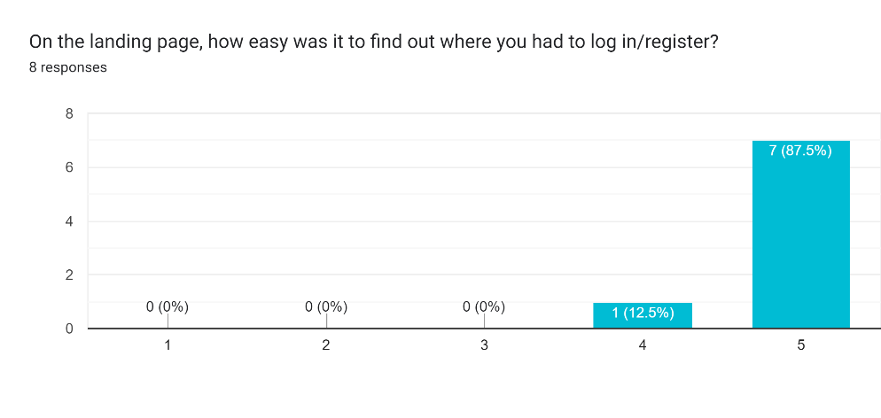

Figure 19. Graph to show how easy users found it to find the login/register option.

1. **Is there anything that could be improved on the landing page to make it more clear?**

The feedback given to this question is that pictures and symbols would be useful to make the site more visually pleasing and to help the users with visual metaphors such as a piece of paper next to recipes.

Another suggestion from the feed back was to make sure the formatting of the words in the navigation bar are not going to a new line, instead make sure they are all on the same line. This would be easily changed and when implementing the design properly, this will not be an issue. Another suggestion for the navigation bar was to remove page name that they are already on to avoid confusion. To counter this, the current page tab is a different colour to show the user where they are on the site.

1. **How simple is it to log in/register to access the site?**

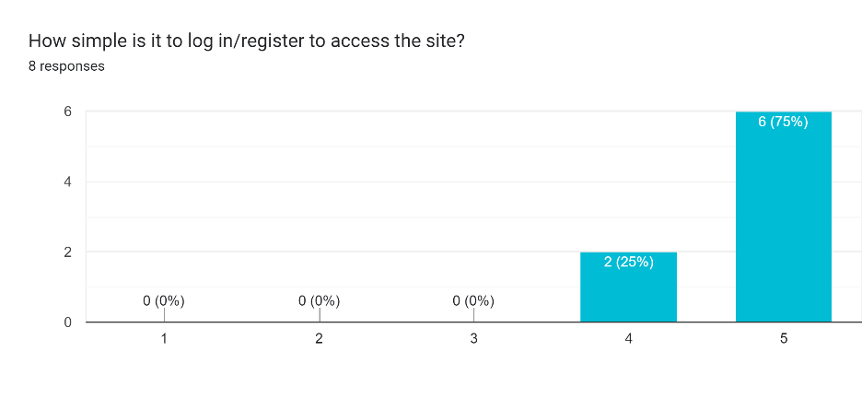

Figure 20. Graph to show how easy users found it to access the site by logging in/registering.

1. **Are there any improvements that you would like to see regarding the login page?**

The feedback for the login page is making sure the users know what the key is and where to find it as well as separating the login and registration page to make them more distinguishable. Another small bit of feedback is making the colours of the buttons the same colour to make the site look more uniform.

While it would be good to split the page into login and registration, having them on the same page means that there will be no need for extra pages. As well as this, the headers above each section clearly label the information the user needs to fill in. Another option, instead of splitting the page, would be to have a switch that adds and removes Divs depending on which whether the switch is on or off.

1. **List the pages you would go through to get to a recipe?**

While there was some variation when users were asked to navigate to view a recipe, the majority of the answers followed the same path of logging in to get to the home page and then selecting the recipes tab. From there they would click on the desired recipe. This short journey from login to the recipes page was intentional as recipes is one of the main tabs in the navigation bar and should be accessed quickly if needed.

Figure 21. Navigation diagram to get to a selected recipe.

1. **How easy is it to find the recipe that you want to view?**

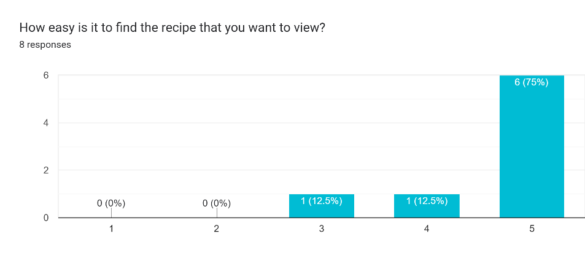

Figure 22. chart for how easy it is to find a recipe.

1. **How clear and/or easy to follow are the recipes? (question on formatting of the page)**

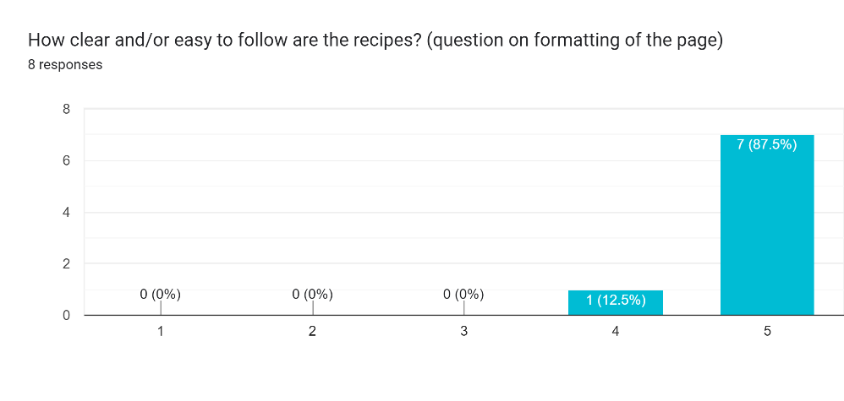

Figure 23. Chart for how easy it is to follow the recipe.

1. **What could be improved with the recipe system?**

One suggestion to improve the recipe system would be to add help buttons next to options to give the user more information on what they could do. Another was to add a dropdown box next to the add to planner to avoid having the popup and reducing the number of clicks. This is a good idea as it will remove the need for a popup and an extra button to confirm or cancel.

1. **What pages would you go through to see your shopping list?**

Like with question 5, the users all gave the same answer and all took the intended route to get to the shopping list. This option is also one of the main navigation bar tabs to allow for quick access.

Figure 24. Navigation diagram to get to the shopping list.

1. **How easy is it to view the shopping list?**

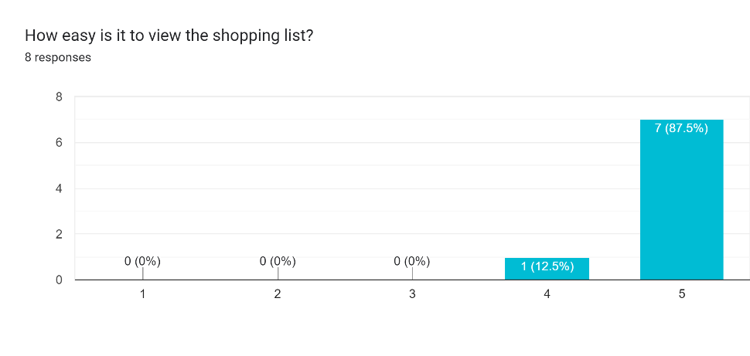

Figure 25. Chart to show the difficulty of viewing the shopping list.

1. **How easy is the shopping list to follow?**

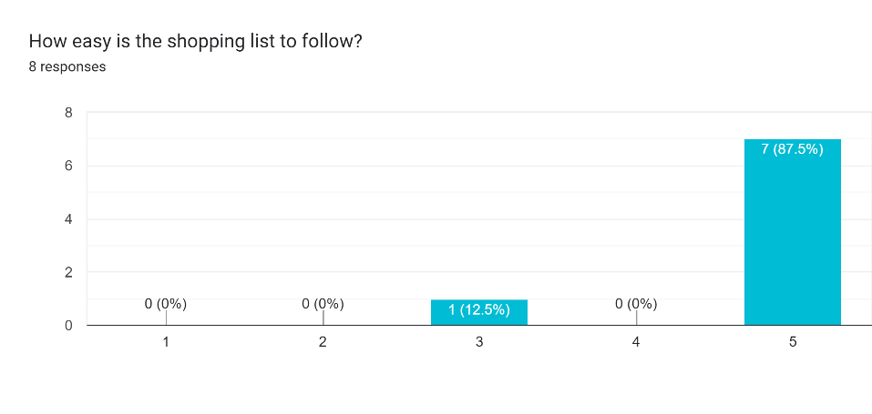

Figure 26. Chart to show difficulty of following the shopping list.

1. **What would you improve about the shopping list feature?**

For the shopping list, users recommended that having an option to add more items to the list that are not on the planner would be helpful. Another is to add more symbols to show categories which items come under e.g. meat, veg and fruit.

Another suggestion was to allow users to add and remove items from the shopping list that may, or may not be needed due to already owning that ingredient or needing to add other important items to the list that are not part of the recipes.

1. **How easy is it to create a recipe?**

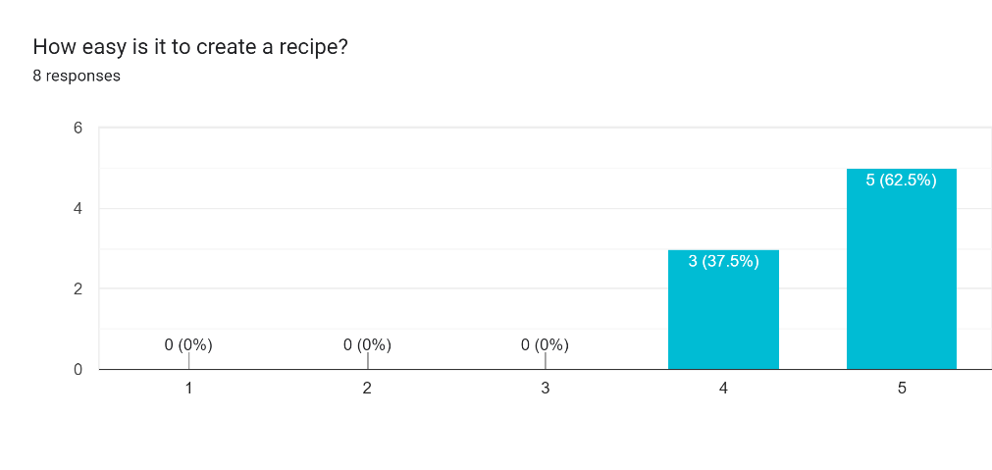

Figure 27. Chart to show the difficulty of creating a recipe.

1. **What could be improved about creating a recipe?**

The user suggested improvements for creating a recipe would be to include different measurement options and a unit converter to make it easier to measure ingredients.

1. **What improvements not already mentioned that you would like to see that could be implemented into the final product?**

Finally, an extra feature that was suggested is to have a page for people to see recently added recipes that they can share that is similar to a Twitter/X feed. This feature was something that was thought about in the early stages but was left as it may be hard to implement in the short time to create the site.

# References

Budiu, R. (2021, July 11). *Why 5 Participants Are Okay in a Qualitative Study, but Not in a Quantitative One*. Retrieved from Nielsen Norman Group logoNielsen Norman Group: https://www.nngroup.com/articles/5-test-users-qual-quant/#:~:text=That%20the%20probability%20of%20someone,the%20issues%20in%20an%20interface.

# Appendix

1. **On the landing page, how easy was it to find out where you had to log in/register?**

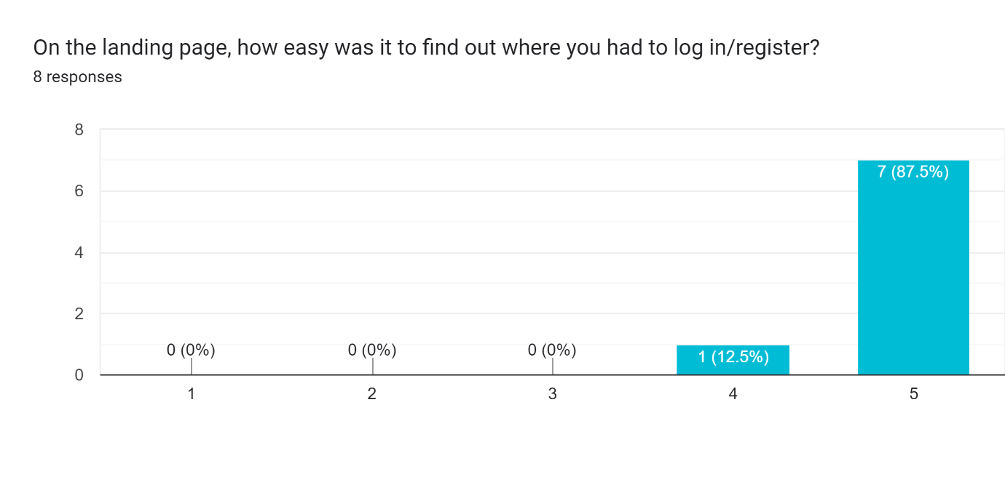

1. **Is there anything that could be improved on the landing page to make it more clear?**

1. **How simple is it to log in/register to access the site?**

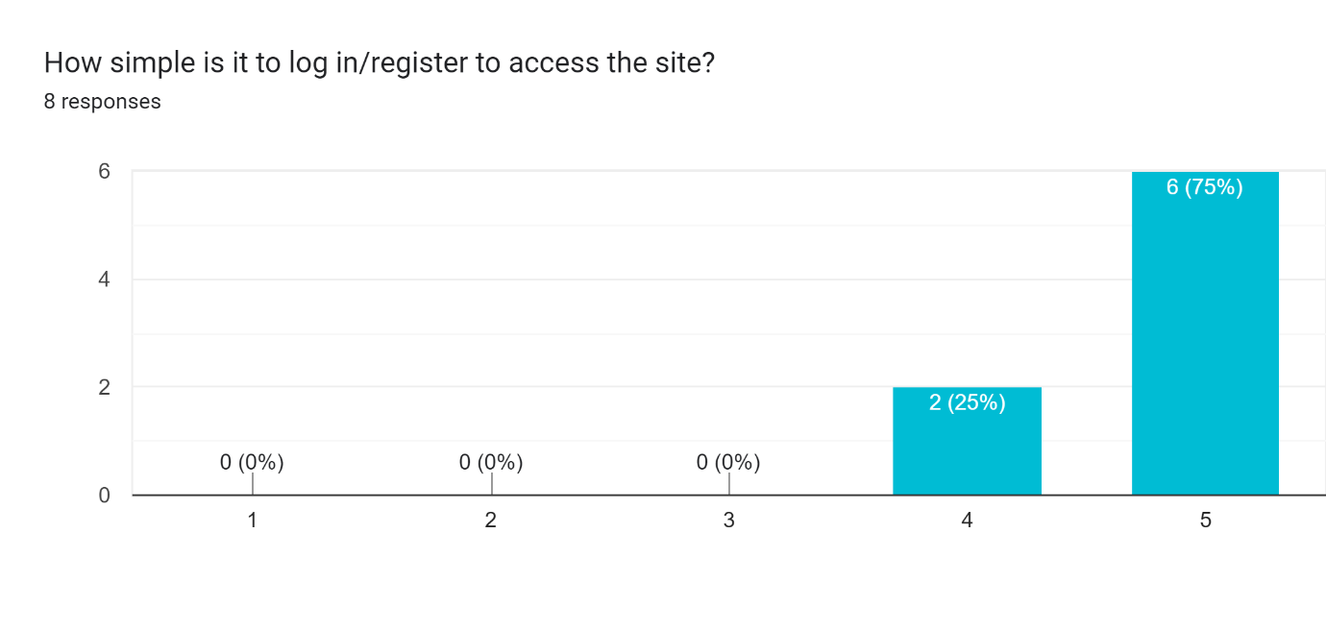

1. **Are there any improvements that you would like to see regarding the login page?**

1. **List the pages you would go through to get to a recipe?**

1. **How easy is it to find the recipe that you want to view?**

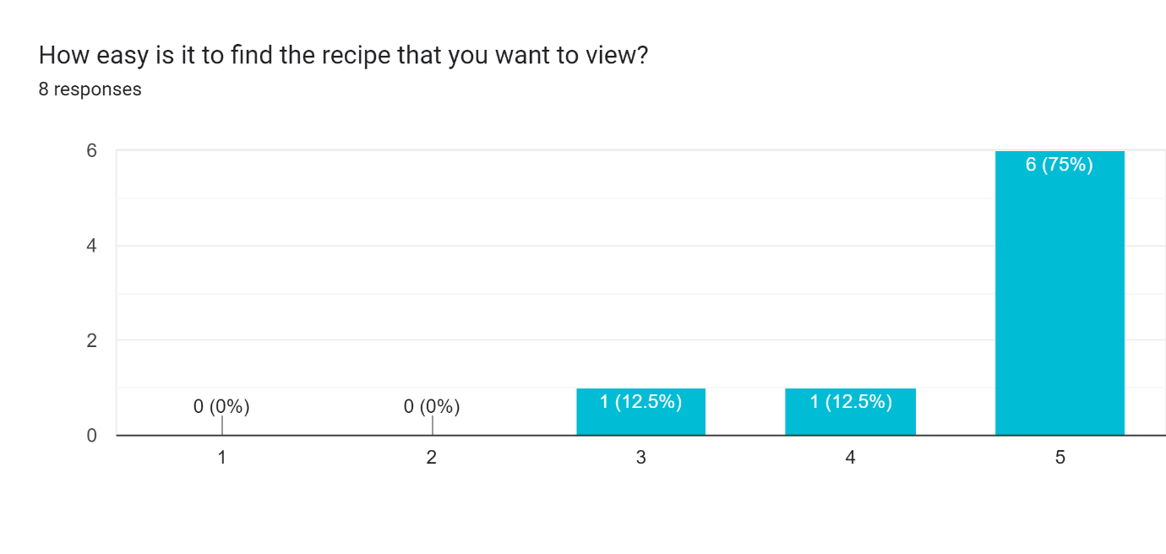

1. **How clear and/or easy to follow are the recipes? (question on formatting of the page)**

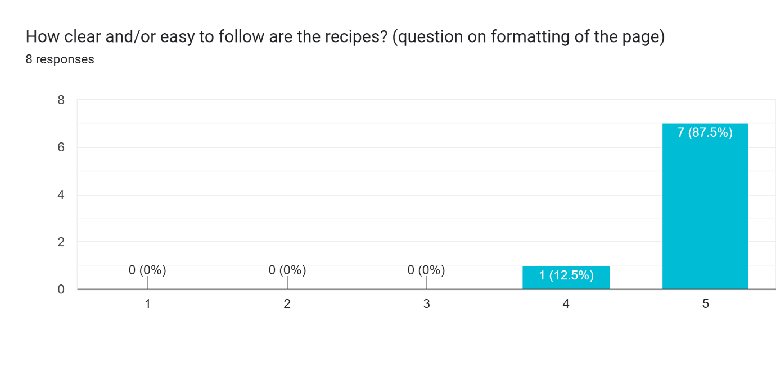

1. **What could be improved with the recipe system?**

1. **What pages would you go through to see your shopping list?**

1. **How easy is it to view the shopping list?**

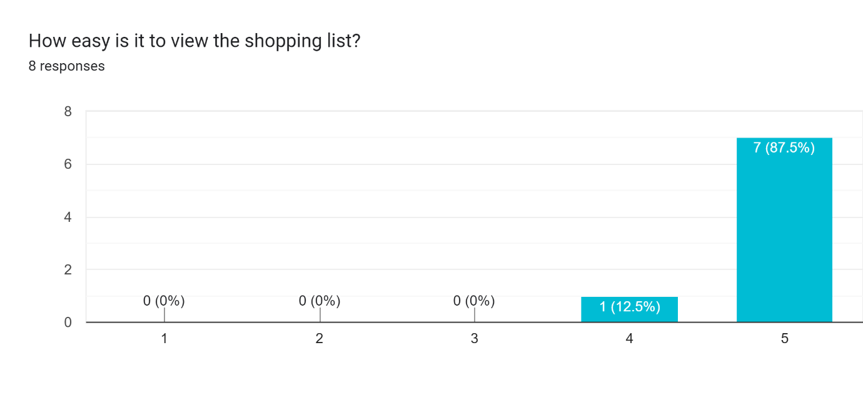

1. **How easy is the shopping list to follow?**

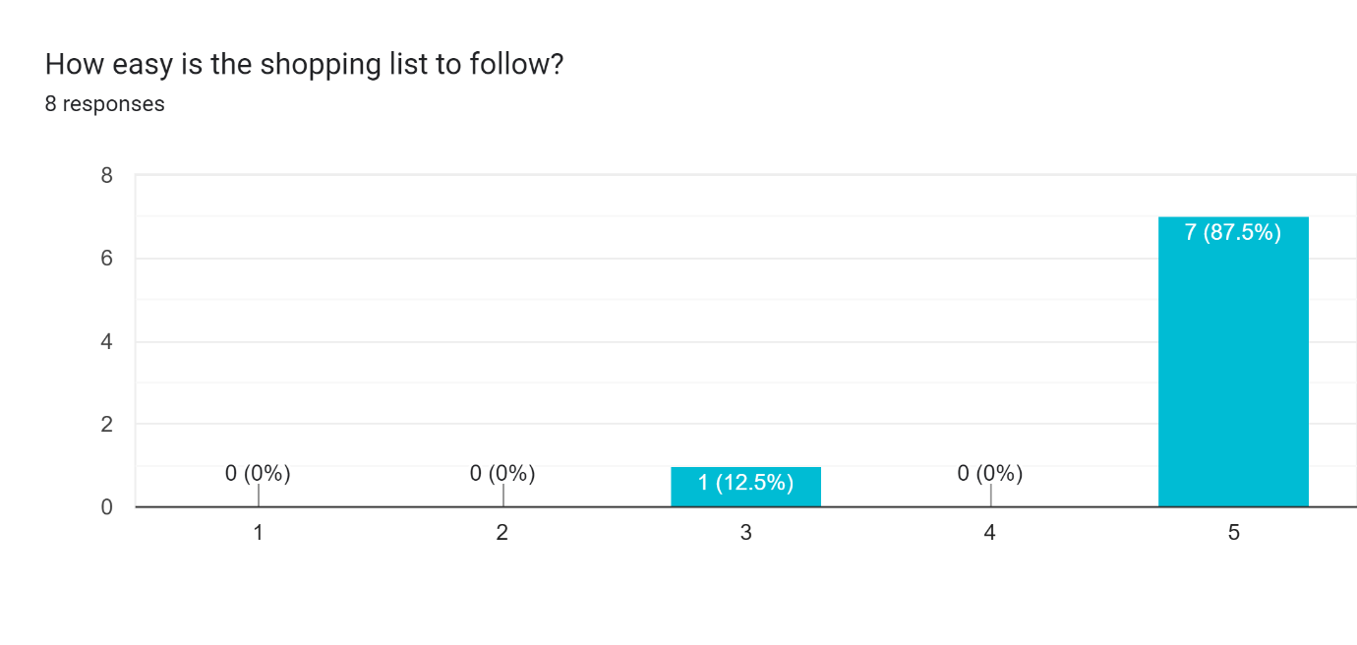

1. **What would you improve about the shopping list feature?**

1. **How easy is it to create a recipe?**

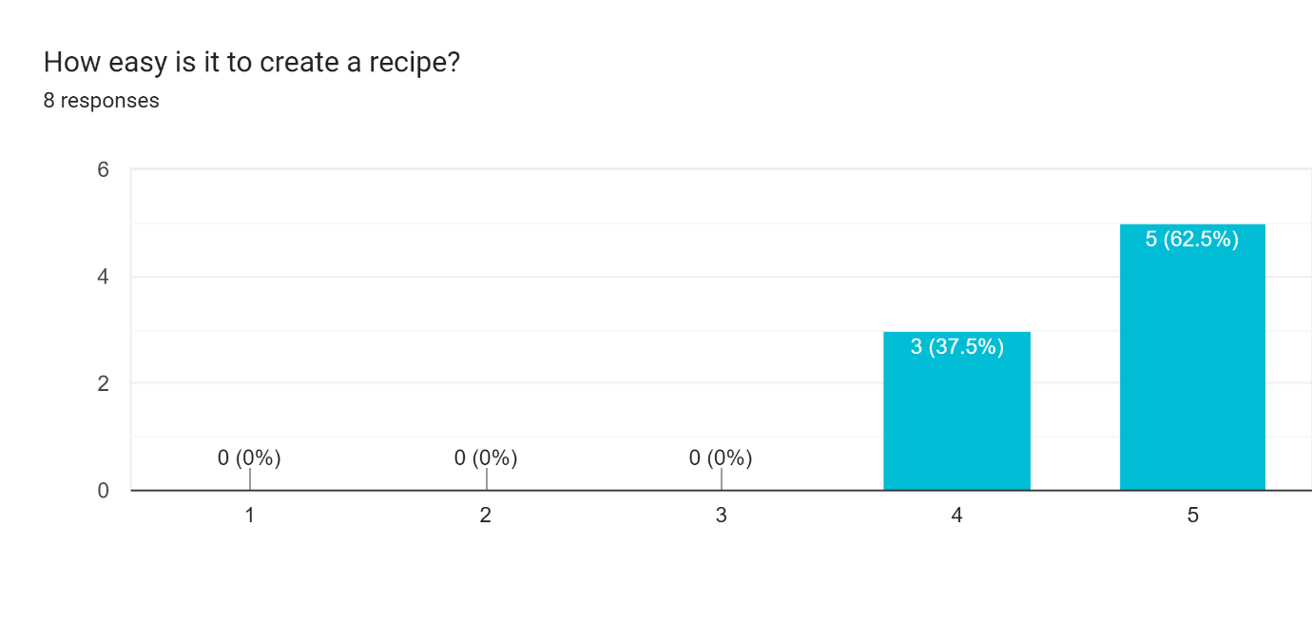

1. **What could be improved about creating a recipe?**

1. **What improvements not already mentioned that you would like to see that could be implemented into the final product?**

